The work done against the MoU with M/S Kaiser Fluids INC., Bangalore, India
- Tezpur University processed Bhot jolokia into dry powder of acceptable particle size. M/S Kaiser Fluids Inc. used their facility to give free flow characteristics to the dried powder with the help of propellant gas and developed an aluminum sprayer that allowed the atomized spray to travel a distance up to 3-4 ft.
- Both parties jointly explored marketing opportunities and were in discussion with many companies. However, no party could be finalized because of the nature of the material.
- IPR could not be generated as there is no novelty in the spray.
A sample of the Bhot jolokia spray is given below.

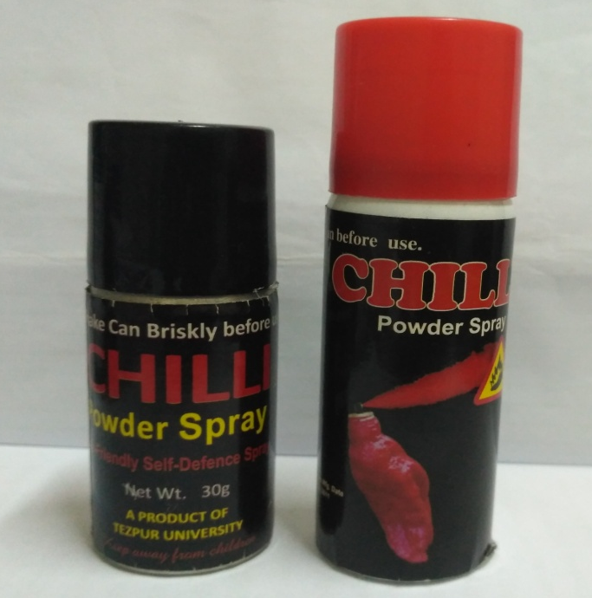
Chilli spray developed at Tezpur University

